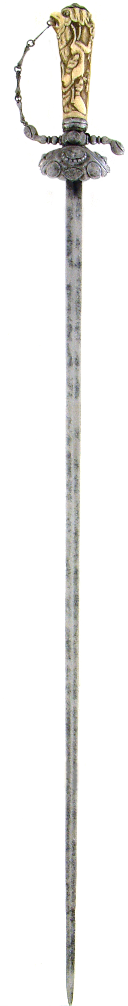 | 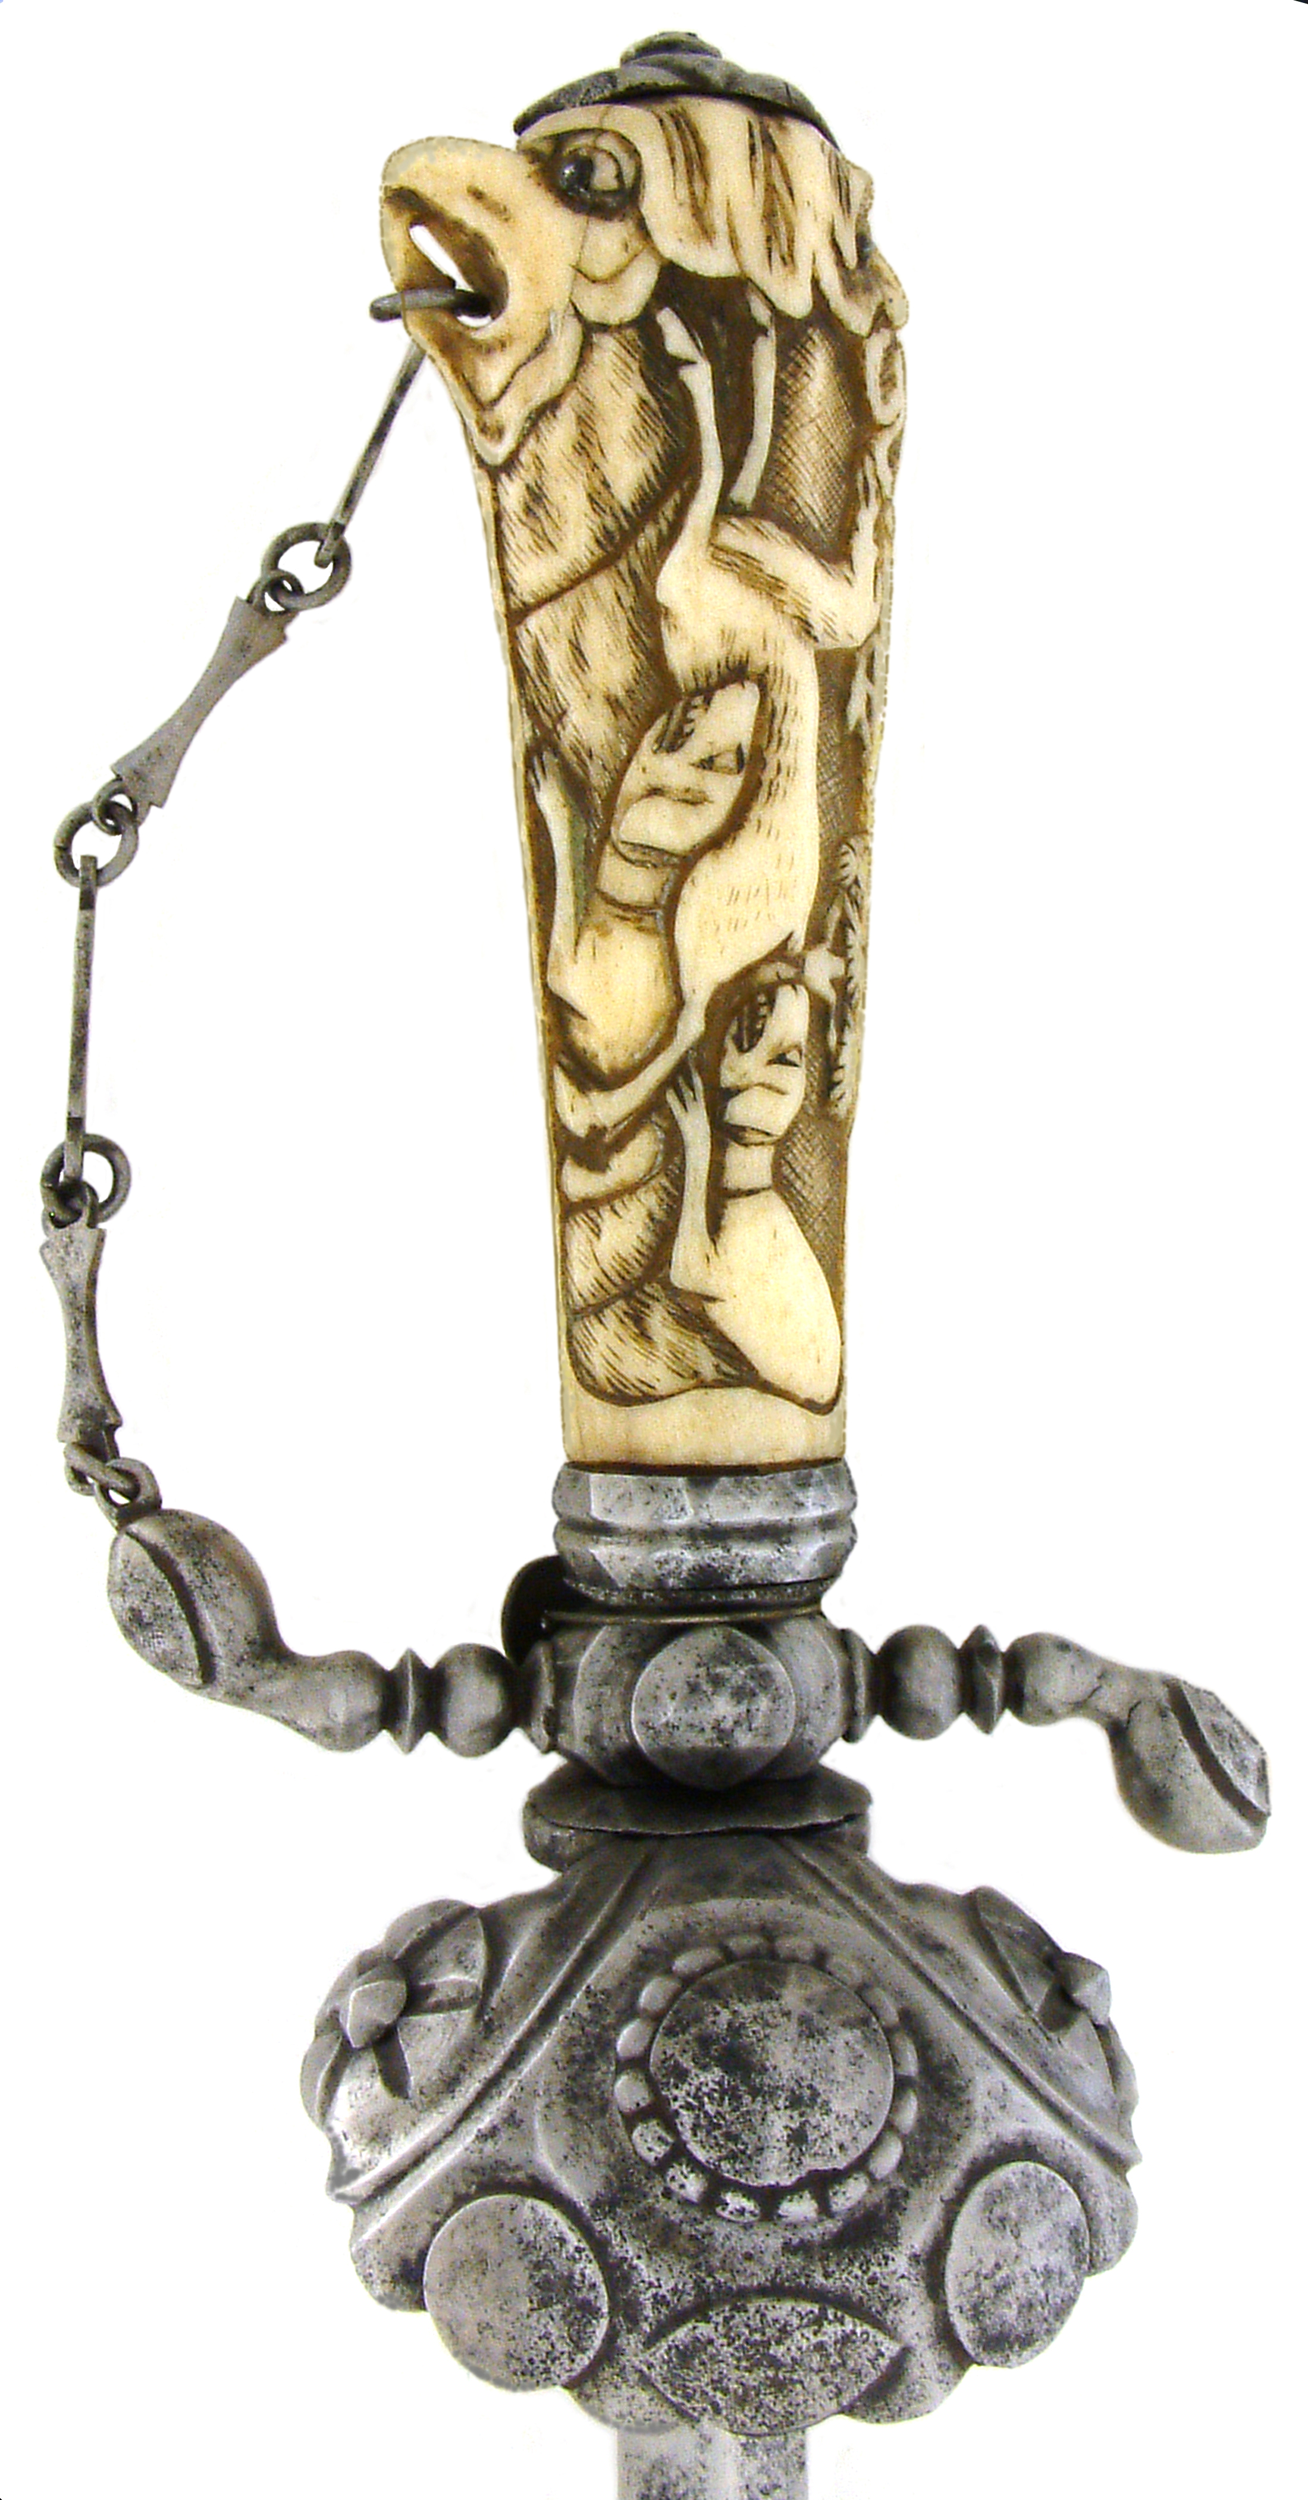 | 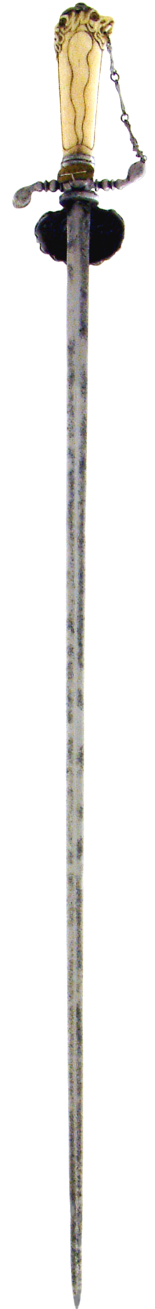
3.2.x Jagddegen

