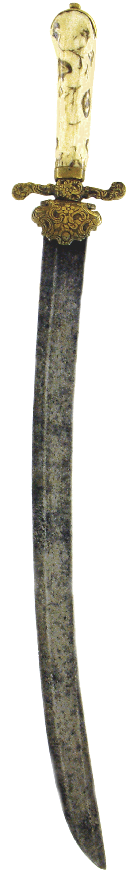 | 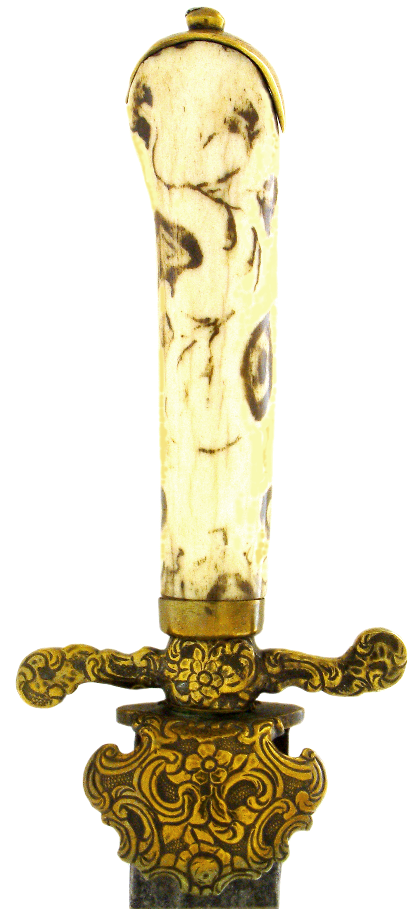 | 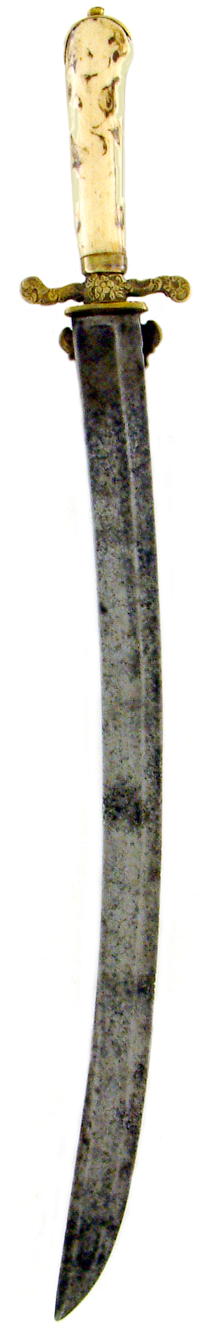

3.2.x Plaute

